Day 1 – Networking Foundations for SOC Analysts:

Objective:

Build a solid foundation in “network traffic analysis” using “Wireshark” focusing on identifying normal network behavior versus potential security risks from a SOC analyst perspective.

Key learning outcomes:

- Alert triage
- Incident investigation
- Threat detection
- Network-based attack identification

Tools Used:

- Wireshark – Network packet capture & analysis
- Windows Command Line / PowerShell – Traffic generation
- Public DNS (8.8.8.8) – Connectivity testing

Tasks Performed:

1. Live Packet Capture

- Captured real-time network traffic on the active interface.
- Generated traffic by browsing websites and sending ICMP requests.
- Verified packet flow and correct interface selection.

Commands Used:

Command Line
Ping –n 20 8.8.8.8

Screenshot Placeholders:
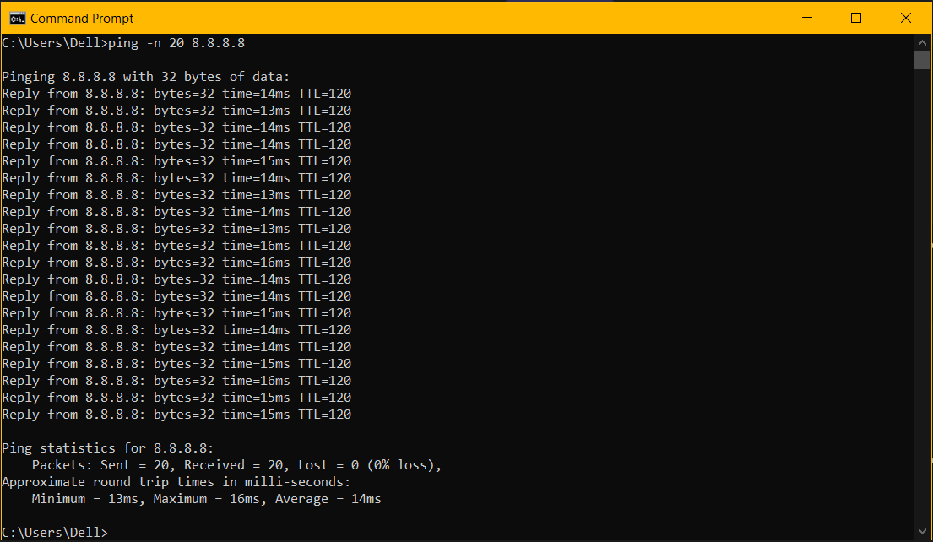

2. Protocol Analysis
Applied Wireshark filters to analyze traffic commonly monitored in SOC environments.
Protocol | Filter Used | SOC Relevance
DNS | dns | Detects command-and-control, data exfiltration
ICMP | icmp | Detects reconnaissance and DoS attacks
TCP | tcp | Session establishment, brute force attempts
HTTPS | tcp.port == 443 | Encrypted communication monitoring

Screenshot Placeholders:
- DNS Traffic:
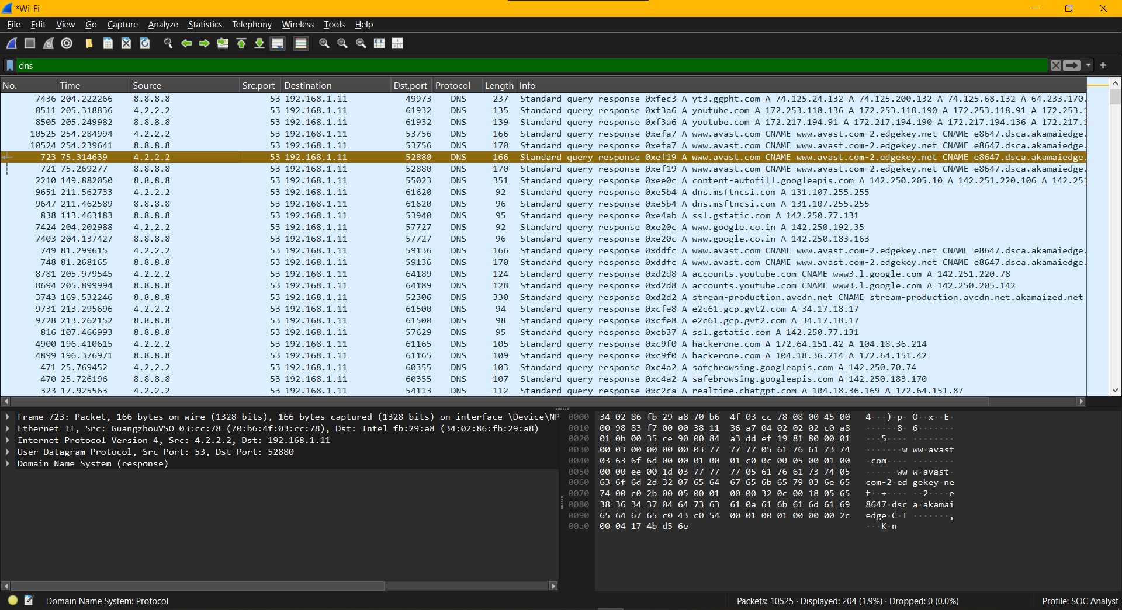
- ICMP Traffic:
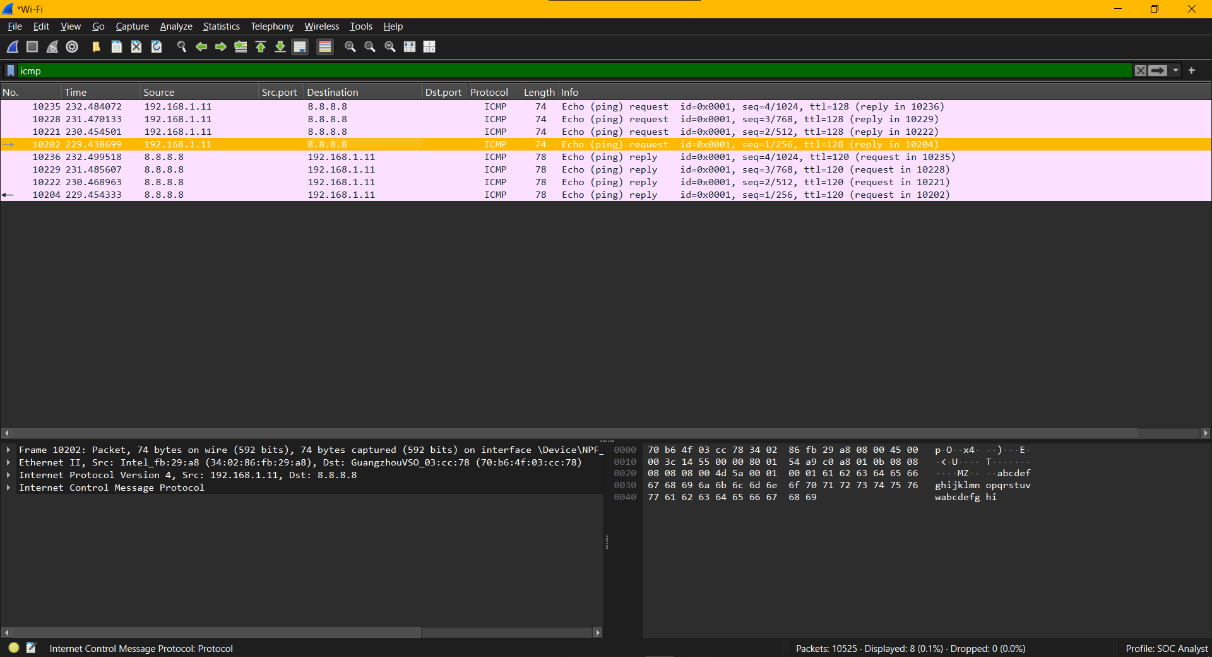
- TCP Handshake:
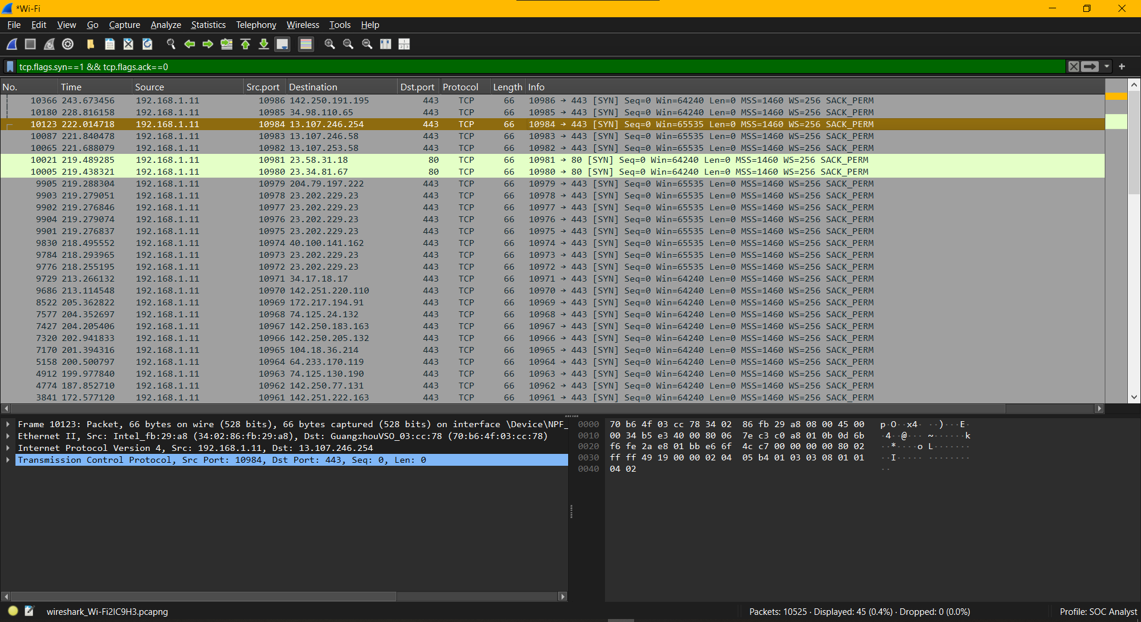

3. TCP Three-Way Handshake Analysis
- Identified SYN → SYN-ACK → ACK sequence.
- Determined:
  - Initiating client
  - Destination server
  - Service ports
- Noted abnormal/incomplete handshakes may indicate:
  - Port scanning
  - SYN flood attacks
Wireshark Filter Command:
tcp.flags.syn==1 && tcp.flags.ack==0
Screenshot Placeholder:


4. Normal vs Suspicious Traffic Evaluation
Baseline normal traffic:
- Standard DNS query patterns
- Normal ICMP request frequency
- Completed TCP sessions
Suspicious activity to monitor:
- Repeated DNS queries to same domain
- High-frequency ICMP traffic
- Multiple SYN packets without completing handshake
- Connections to unusual or unknown external IPs
Screenshot Placeholder:
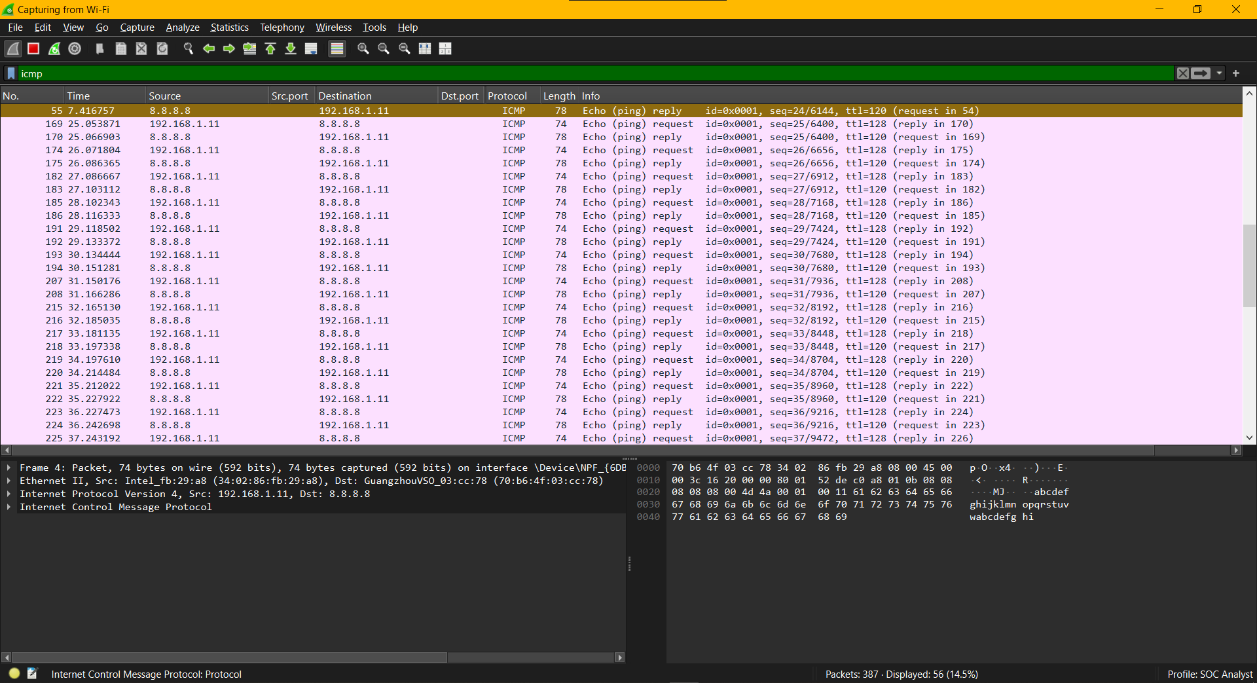

Security Concepts Demonstrated
- Network reconnaissance detection
- Protocol-level traffic analysis
- Baseline behavior identification
- Early-stage attack awareness
- SOC triage mindset

Key Observations
- DNS traffic is a valuable indicator for malware or C2 detection.
- ICMP traffic can be abused for scanning and flooding.
- TCP handshake analysis helps detect abnormal connection attempts.
- Establishing normal network patterns is essential before writing or tuning SIEM rules.

Skills Gained
- Packet capture & filtering
- Network traffic interpretation
- SOC-style traffic analysis
- Threat detection mindset
- Documentation & reporting

